My Definition  Linear Functions | Characteristics
Examples  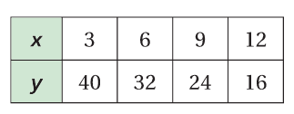  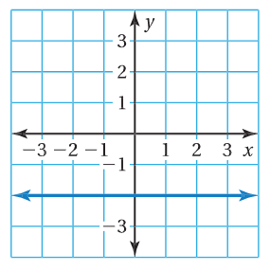  $$Y=2x+4$$ | Non-Examples  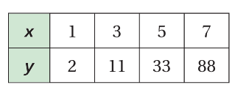  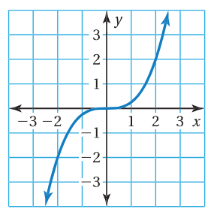  $$y=\frac{4}{x} y=3-x^{3}$$

Linear Function Practice (6.4)
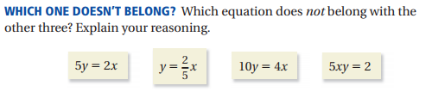
1.)

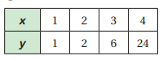
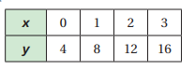
Determine whether each table or graph represents a linear or nonlinear function (circle one). If it is linear, write a linear function that relates x to y. If it is not linear, explain why.
2.) 3.)

Linear or Nonlinear Linear or Nonlinear
Equation or explanation: Equation or explanation:

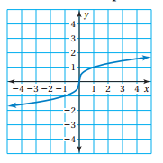
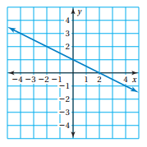
4.) 5.)

Linear or Nonlinear Linear or Nonlinear
Equation or explanation: Equation or explanation:

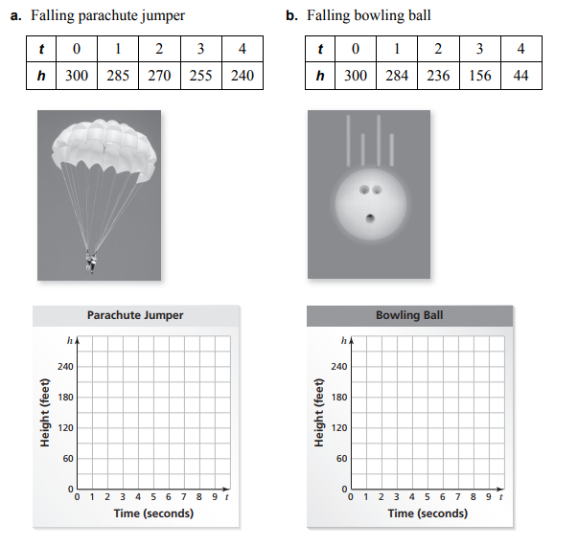
Graph the data in each table. Decide whether each graph is linear or nonlinear.

Compare the two falling objects. Which one has an increasing (not constant) speed?

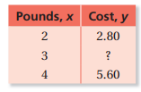
The table shows the cost y (in dollars) of x pounds of sunflower seeds.
a. What is the missing y-value that makes the table represent a linear function?

b. Write a linear function that represents the cost y of x pounds of seeds.

c. Interpret the slope of the function.

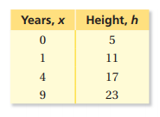
TREES Tree A is 5 feet tall and grows at a rate of 1.5 feet per year. The table shows the height h (in feet) of Tree B after x years.
- Does the table represent a linear or nonlinear function? Explain.

- Write a linear equation for Tree A.

- Write a linear equation for Tree B.

- Which tree is taller after 10 years? Explain.

- Create a graph representing both trees heights. Which tree is growing at a faster rate?

